SKILL WEEK - 4
Task 1
Code :-
#include <stdio.h>
#include <string.h>

#define MAX_INPUT 1024
#define MAX_TOKENS 100

int tokenize(char *input, char *tokens[])
{
int count = 0;

char *token = strtok(input, " \t\n");

while (token != NULL && count < MAX_TOKENS - 1)
{
tokens[count++] = token; token = strtok(NULL, " \t\n");
}

tokens[count] = NULL; return count;
}

int validate_tokens(char *tokens[], int count)
{ if (count == 0)
{
printf("Empty command\n");
return 0;
}

for (int i = 0; i < count; i++)
{
if (strcmp(tokens[i], "|") == 0 &&
(i == 0 || i == count - 1))
{
printf("Syntax Error: Invalid pipe position\n"); return 0;
}
}

return 1;
}

void display_tokens(char *tokens[], int count)
{
printf("\nTokens:\n");

for (int i = 0; i < count; i++)
{
printf("Token %d: %s\n", i + 1, tokens[i]);
}
}

int main()
{
char input[MAX_INPUT];
char *tokens[MAX_TOKENS];

while (1)
{
printf("\nmyshell> ");

if (fgets(input, sizeof(input), stdin) == NULL) break;

input[strcspn(input, "\n")] = '\0';

if (strcmp(input, "exit") == 0) break;

int count = tokenize(input, tokens);

if (!validate_tokens(tokens, count)) continue;

display_tokens(tokens, count);
}

return 0;
}
OUTPUT:-
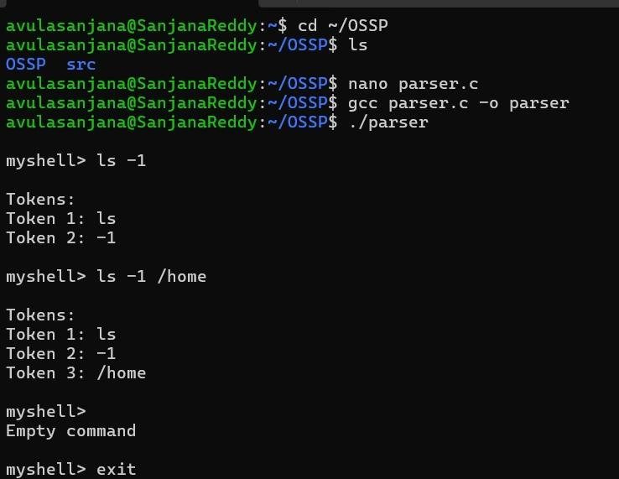
Task 2:
Code:- #include <stdio.h>
#include <stdlib.h>
#include <string.h>
#include <unistd.h>
#include <sys/wait.h>

#define MAX_INPUT 1024
#define MAX_ARGS 100

int parse_command(char *input, char *args[])
{
int count = 0;
char *p = input;

while (*p != '\0')
{
// Skip spaces while (*p == ' ' || *p == '\t') p++;

if (*p == '\0')
break;

// Single quoted string if (*p == '\'')
{
p++;

args[count] = p;

while (*p != '\'' && *p != '\0') p++;
// Unmatched quote if (*p == '\0')
{
printf("\nSyntax Error: Unmatched single quote.\n"); return -1;
}

*p = '\0';
p++;

count++;
} else
{
// Normal argument
args[count] = p;

while (*p != ' ' && *p != '\t' && *p != '\0') p++;
if (*p != '\0')
{
*p = '\0'; p++;
}

count++;
}
}

args[count] = NULL; return count;
}

int main()
{
char input[MAX_INPUT];
char *args[MAX_ARGS];

while (1)
{
printf("\nmyShell> ");
fflush(stdout);

if (fgets(input, sizeof(input), stdin) == NULL) break;

input[strcspn(input, "\n")] = '\0';

if (strcmp(input, "exit") == 0) break;

int count = parse_command(input, args);

if (count == -1)
continue;

if (count == 0)
continue;

printf("\nParsing Result:\n");

for (int i = 0; i < count; i++)
{
printf("Argument %d: %s\n", i + 1, args[i]);
}

pid_t pid = fork();

if (pid < 0)
{
perror("fork"); continue;
}

if (pid == 0)
{
execvp(args[0], args);

perror("execvp"); exit(1);
} else
{
printf("\nChild PID: %d\n", pid);

waitpid(pid, NULL, 0);

printf("\nCommand execution completed.\n");
}
}

return 0; }
OUTPUT:-
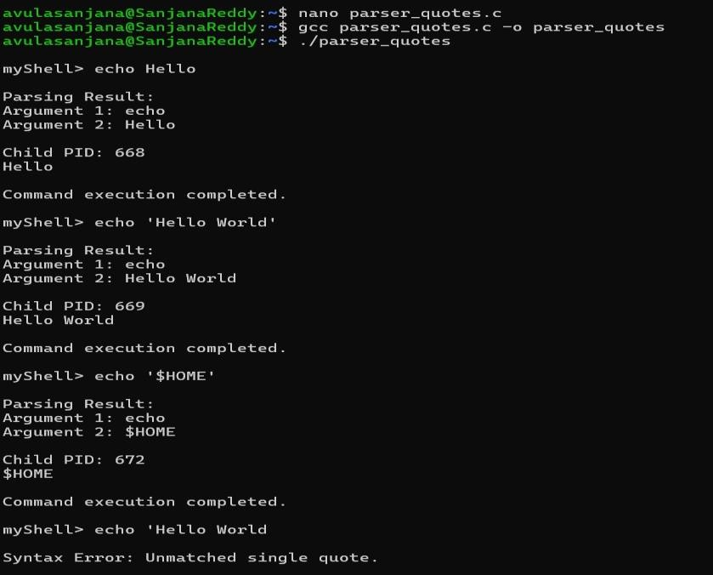
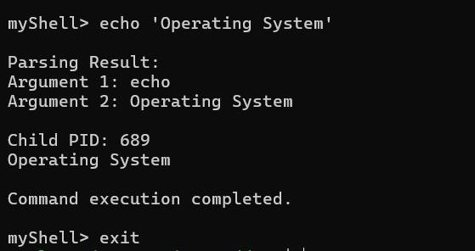
Task3 :-
Code:-
#include <stdio.h>
#include <stdlib.h>
#include <string.h>
#include <unistd.h>
#include <sys/wait.h>

#define MAX_INPUT 1024
#define MAX_ARGS 100

int parse_command(char *input, char *args[])
{
int count = 0;
char *p = input;

while (*p != '\0')
{
// Skip spaces
while (*p == ' ' || *p == '\t') p++;

if (*p == '\0')
break;

// Double quoted argument if (*p == '"')
{
p++; args[count] = p;

while (*p != '"' && *p != '\0') p++;
// Check unmatched double quote
if (*p == '\0')
{
printf("\nSyntax Error: Unmatched double quote.\n"); return -1;
}

*p = '\0';
p++;

count++;
} else
{
// Normal argument
args[count] = p;

while (*p != ' ' && *p != '\t' && *p != '"' && *p != '\0') p++;

if (*p == '"')
{
printf("\nSyntax Error: Unexpected double quote.\n"); return -1;
}
if (*p != '\0')
{
*p = '\0'; p++;
}

count++;
}
}

args[count] = NULL;
return count;
}

/* Expand $USER and other environment variables */
void expand_variables(char *args[], int count)
{ for (int i = 0; i < count; i++)
{
char result[MAX_INPUT] = ""; char *p = args[i];

while (*p != '\0')
{ if (*p == '$')
{
char variable[100]; int j = 0;

p++;

while ((*p >= 'A' && *p <= 'Z') || (*p >= 'a' && *p <= 'z') ||
(*p >= '0' && *p <= '9') ||
*p == '_')
{
variable[j++] = *p; p++;
}

variable[j] = '\0';

char *value = getenv(variable);

if (value != NULL) strcat(result, value);
} else
{
int len = strlen(result); result[len] = *p; result[len + 1] = '\0'; p++;
}
}

strcpy(args[i], result);
}
}

int main()
{
char input[MAX_INPUT];
char *args[MAX_ARGS];

while (1)
{
printf("\nmyShell> ");
fflush(stdout);

if (fgets(input, sizeof(input), stdin) == NULL) break;

input[strcspn(input, "\n")] = '\0';

if (strcmp(input, "exit") == 0) break;

if (strlen(input) == 0)
continue;

int count = parse_command(input, args);

if (count == -1)
continue;

if (count == 0)
continue;

// Allocate buffers for variable expansion
char expanded[MAX_ARGS][MAX_INPUT];

for (int i = 0; i < count; i++)
{
strcpy(expanded[i], args[i]); args[i] = expanded[i];
}
// Expand environment variables expand_variables(args, count);

printf("\n--- Parsed Arguments ---\n");

for (int i = 0; i < count; i++)
{
printf("Argument %d: %s\n", i + 1, args[i]);
}

pid_t pid = fork();

if (pid < 0)
{
perror("fork"); continue;
}

if (pid == 0)
{
printf("\nChild Process\n");
printf("PID = %d\n\n", getpid());

execvp(args[0], args);

perror("execvp"); exit(1); } else
{
waitpid(pid, NULL, 0);

printf("\nChild process completed.\n");
}
}

return 0; }
Ouput:-
